Hack Keele Branding

Square Logo (for profile pictures etc):

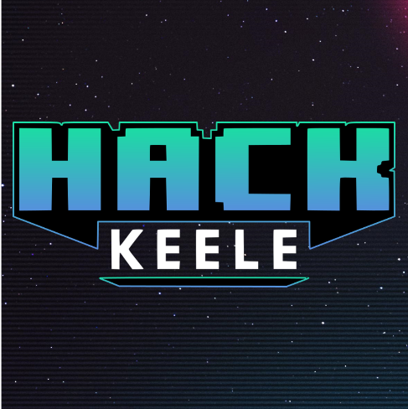

Normal Logo:

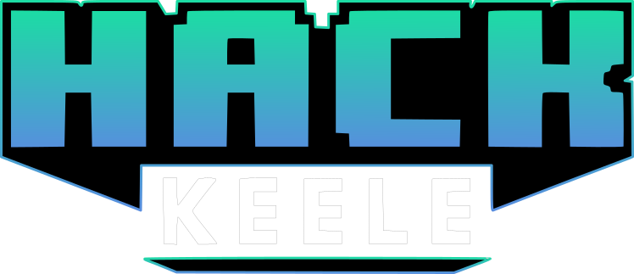

Header Picture:

tbc

## 8bit font (for headings/titles)

Press Start 2P - (https://fonts.google.com/specimen/Press+Start+2P)

## Normal font (for all other text)

Montserrat - (https://fonts.google.com/specimen/Montserrat?selection.family=Montserrat)

## Theme colours

Black, white, #7A5FFF, #01FF89, #666666,

## Style references

“Synthwave” “retrowave” “cyberpunk” “80’s retro” “tron” “outrun”